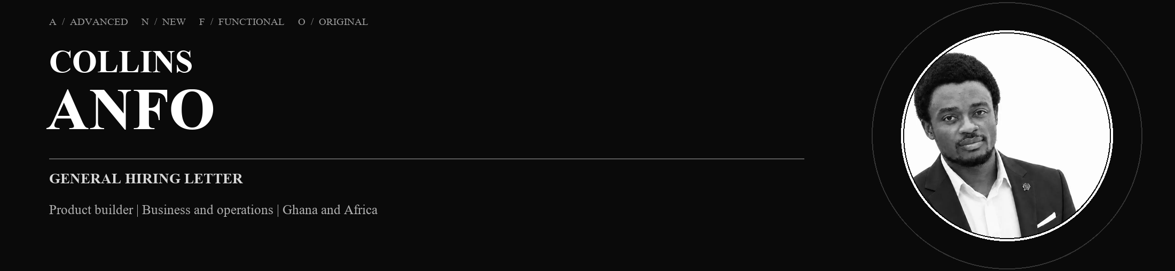
Location: Hoppstädten-Weiersbach, Germany
Email: collinsanfo24@gmail.com · Phone: +49 162 7445475
LinkedIn: linkedin.com/in/collinsanfo · Portfolio: collins-anfo-portfolio-2026.collinsanfo24.chatgpt.site
What I bring if hired
If I join a team, I bring a builder's curiosity, operational discipline and the willingness to learn what the work requires. My value is not that I already know everything. It is that I can begin close to the problem, create order from ambiguity and keep moving towards a useful, testable result.
01 UNDERSTAND THE REAL PROBLEM
I listen, research and map the process or user need before deciding what should be built or changed.
02 TURN IDEAS INTO VISIBLE WORK
I shape workflows, document decisions, prototype the next step and check the result against the job it must do.
03 BRING OPERATIONAL DISCIPLINE
Experience across inventory, logistics, production, service and project support helps me notice standards, handoffs and follow-through.
04 USE AI RESPONSIBLY
I use AI for research, learning, drafts and prototypes under human review, without presenting assisted work as expertise I have not earned.
05 OWN THE WORK AND COLLABORATE
I can move work forward independently and involve experienced teammates or specialists whenever they can make the result stronger.
Evidence in practice: GroomDocs is live and free. GroomLinq is an ambitious Ghana-first marketplace in development.
If hired, I would be most useful where a team needs someone who can connect customer reality, business operations and product execution; learn quickly; make the next step visible; and take responsibility for moving the work forward.
COLLINS ANFO · PRODUCT BUILDER · OPERATIONS · GHANA / AFRICA

