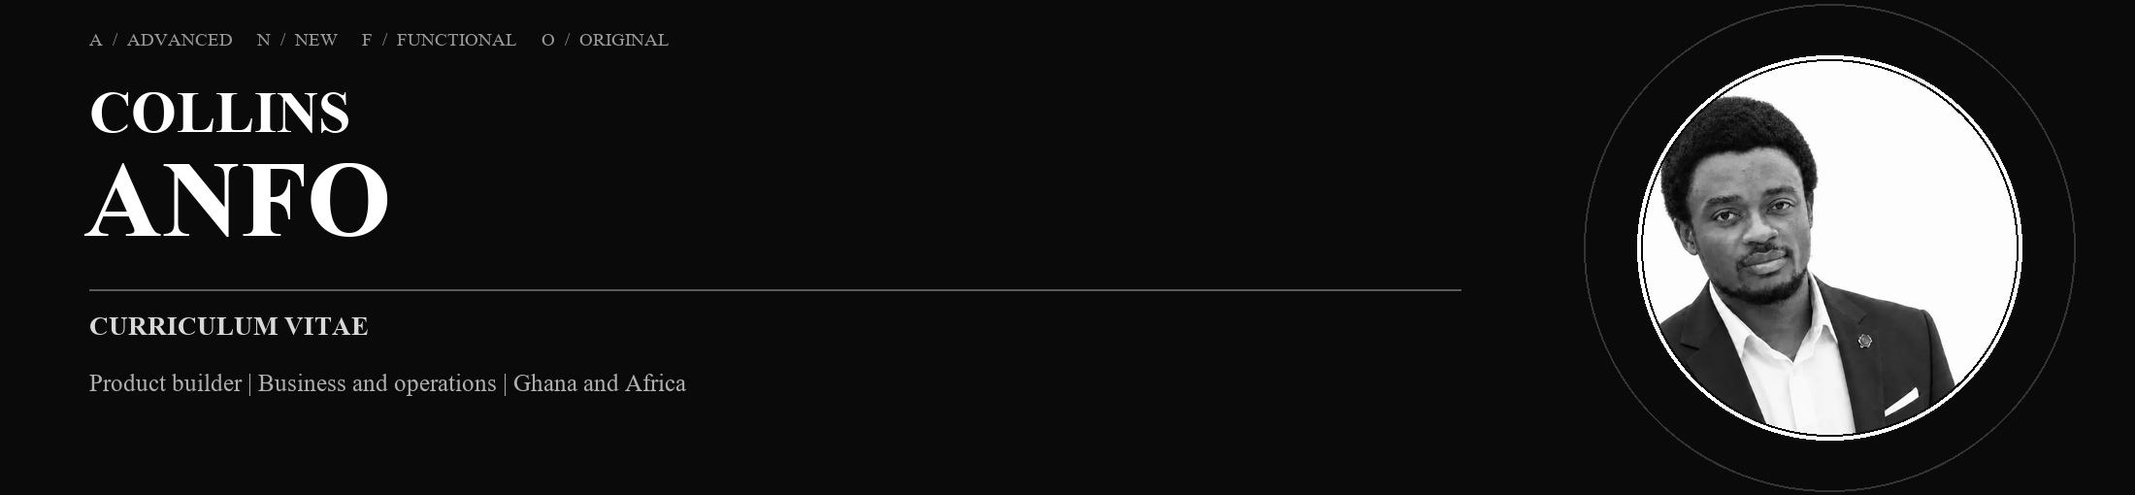
Location: Hoppstädten-Weiersbach, Germany
Email: collinsanfo24@gmail.com · Phone: +49 162 7445475
LinkedIn: linkedin.com/in/collinsanfo · Portfolio: collins-anfo-portfolio-2026.collinsanfo24.chatgpt.site
I turn lived problems into useful, testable products.
01 / PROFILE
Product builder and founder with a background in international business, operations and hands-on delivery. I begin with lived problems, especially everyday challenges in Ghana and across Africa, then learn what the solution requires. I use research, product thinking, clear documentation and carefully supervised AI tools to move ideas into visible, testable products. I work independently when useful and seek experienced collaborators when stronger craft or judgement is needed.
02 / WHAT I BRING
01 PROBLEM FRAMING
Turn lived frustrations and operational gaps into clear product questions and priorities.
02 PRODUCT THINKING
Shape workflows, interfaces, documentation and testable next steps around real user needs.
03 AI-ASSISTED BUILDING
Use AI to research, learn and prototype while keeping decisions and quality under human review.
04 OPERATIONS
Bring practical experience with inventory, logistics, service, schedules, budgets and team communication.
03 / SELECTED FOUNDER WORK
GROOMDOCS LIVE
Free, privacy-first browser PDF tools built after repeated frustration with paywalls; files remain on the device.
GROOMLINQ IN DEVELOPMENT
Ghana-first marketplace exploring seven different transaction models and purchase-verified discovery.
GHANAONE CONCEPT
Independent specification and interface direction for a clearer digital front door to public services; no government involvement is claimed.
GROOMCV PROTOTYPE
Career workspace concept organised around role fit, evidence and visible skill gaps.
04 / TOOLS AND WORKING METHODS
Roles I am growing into. Product, product-operations and AI-assisted delivery roles where practical judgement, learning speed and collaboration matter.
Problem framing, user journeys, interface decisions, product specifications, documentation, prototypes, ChatGPT, Claude, Cursor and Gemini.
05 / PROFESSIONAL EXPERIENCE
Assistant Production Associate | Pommes Freunde
Saarbruecken, Germany | May 2025 - Jun 2026
Managed daily inventory and ordering, prepared menu items to recipe and safety standards, and handled customer orders and enquiries.
Logistics Assistant | GLS
Neunkirchen, Germany | Aug 2024 - Dec 2024
Processed inbound shipments with quality checks and accurate records; organised goods and prepared outbound orders.
Sortation Associate | Amazon
Ramstein-Miesenbach and Grolsheim, Germany | Sep 2022 - Apr 2024
Scanned and inducted 80-100 packages per minute, sorted delivery routes and updated warehouse data with scanner systems.
Warehouse Associate (part-time) | Rofu Kinderland
Hoppstaedten-Weiersbach, Germany | Oct 2023 - Dec 2023
Picked goods, handled price labelling, packaging and returns.
Service Crew | McDonald's
Idar-Oberstein, Germany | May 2022 - Jul 2022
Maintained food-safety standards, supported kitchen preparation and handled customer sales.
Teacher / Intern | Ebenezer Methodist Preparatory & JHS
Kumasi, Ghana | Aug 2021 - Dec 2021
Taught eight subjects to 35 pupils; introduced the school's first Excel gradebook and created digital learning aids.
Assistant Project Manager / Intern | X-Quisite Plus
Kumasi, Ghana | May 2020 - Sep 2020
Reported milestones, supported budget, schedule and scope control, and negotiated supplier quotations and contracts.
06 / EDUCATION
Bachelor of Engineering studies - Sustainable Business and Technology. Hochschule Trier, Umwelt-Campus Birkenfeld, Germany | Studies through 2028
Bachelor of Science - International Business Management. Kwame Nkrumah University of Science and Technology, Kumasi, Ghana | Completed Sep 2023
07 / COURSEWORK AND LICENCES
SAP S/4HANA coursework - Udemy and Great Learning, 2026
Prompt Engineering for ChatGPT - Vanderbilt University / Coursera, 2024
Generative AI Fundamentals, five-course specialisation - IBM / Coursera, 2024
Forklift licence - AGG Staplerschule Frankfurt, 2025
08 / LANGUAGES
English - fluent | German - basic conversational
09 / EXTRA ACTIVITIES
Erasmus+ scholar | X-Culture international team project
10 / CREATIVE WORK
Two independently published books on Amazon KDP | Creator of Gaimase music

